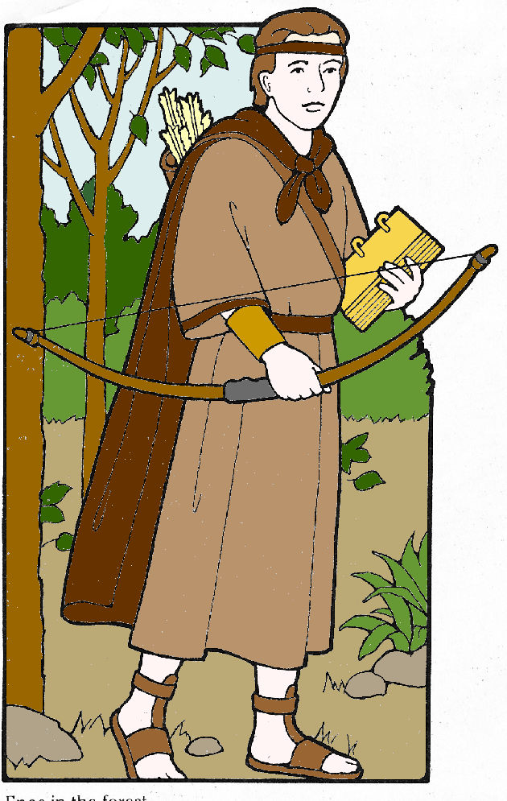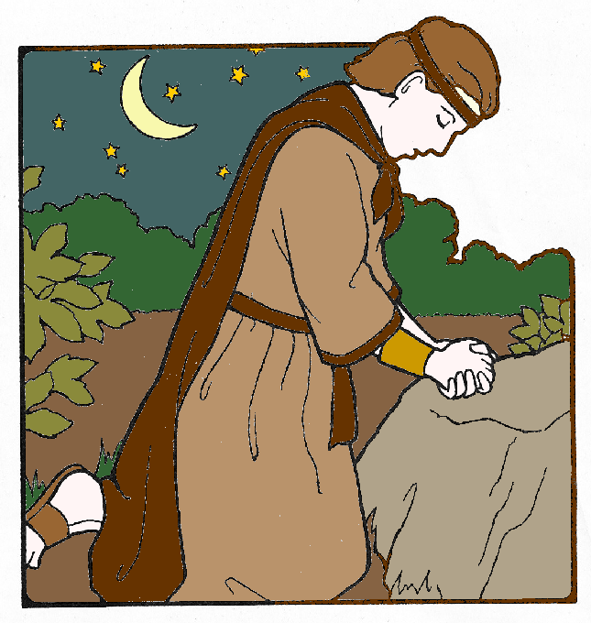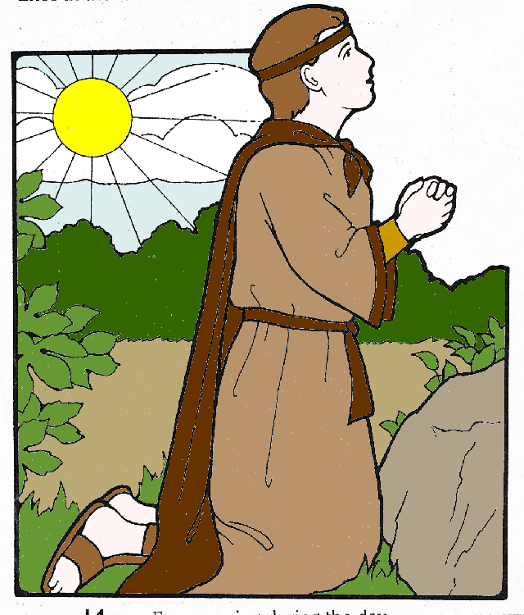

Resources :
Enos Praying - The Friend, September 2000, “Enos and the Power of Prayer”.
The Lamanites and Nephites - Chapter 11 of Book of Mormon Stories.

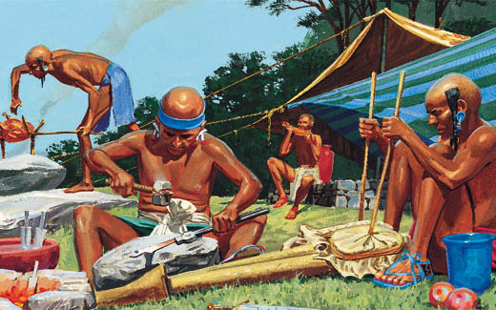
The Lamanites

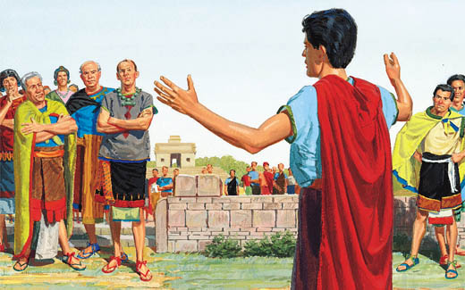
The Nephites

