[Book of Mormon Scripture Figures: “Jesus Heals the Sick and Blesses Children”](http://media.ldscdn.org/pdf/magazines/friend-september-2012/2012-09-30-book-of-mormon-scripture-figures-eng.pdf) (September 2012 Friend). Hearts and Envelope: Microsoft Word clipart.

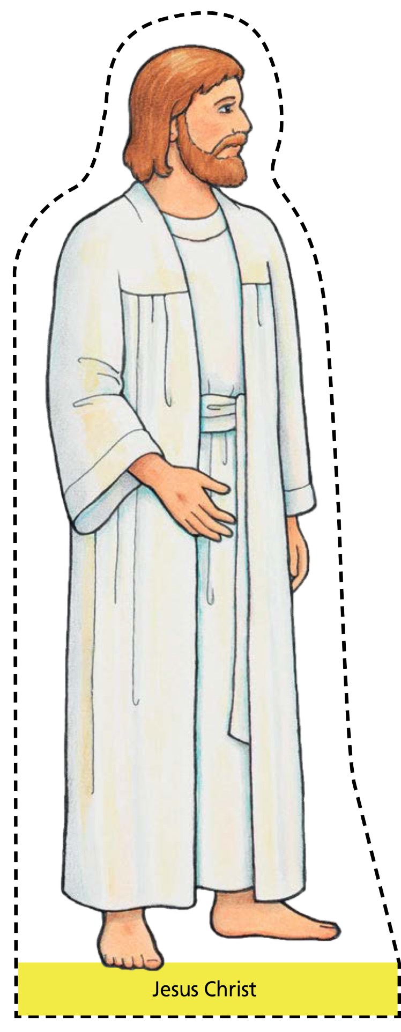

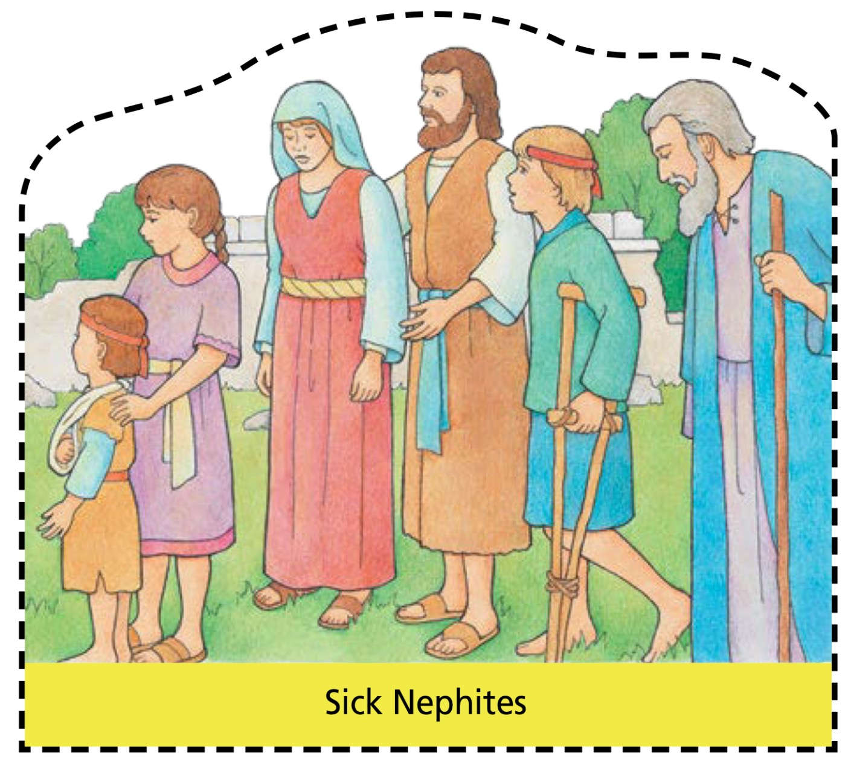

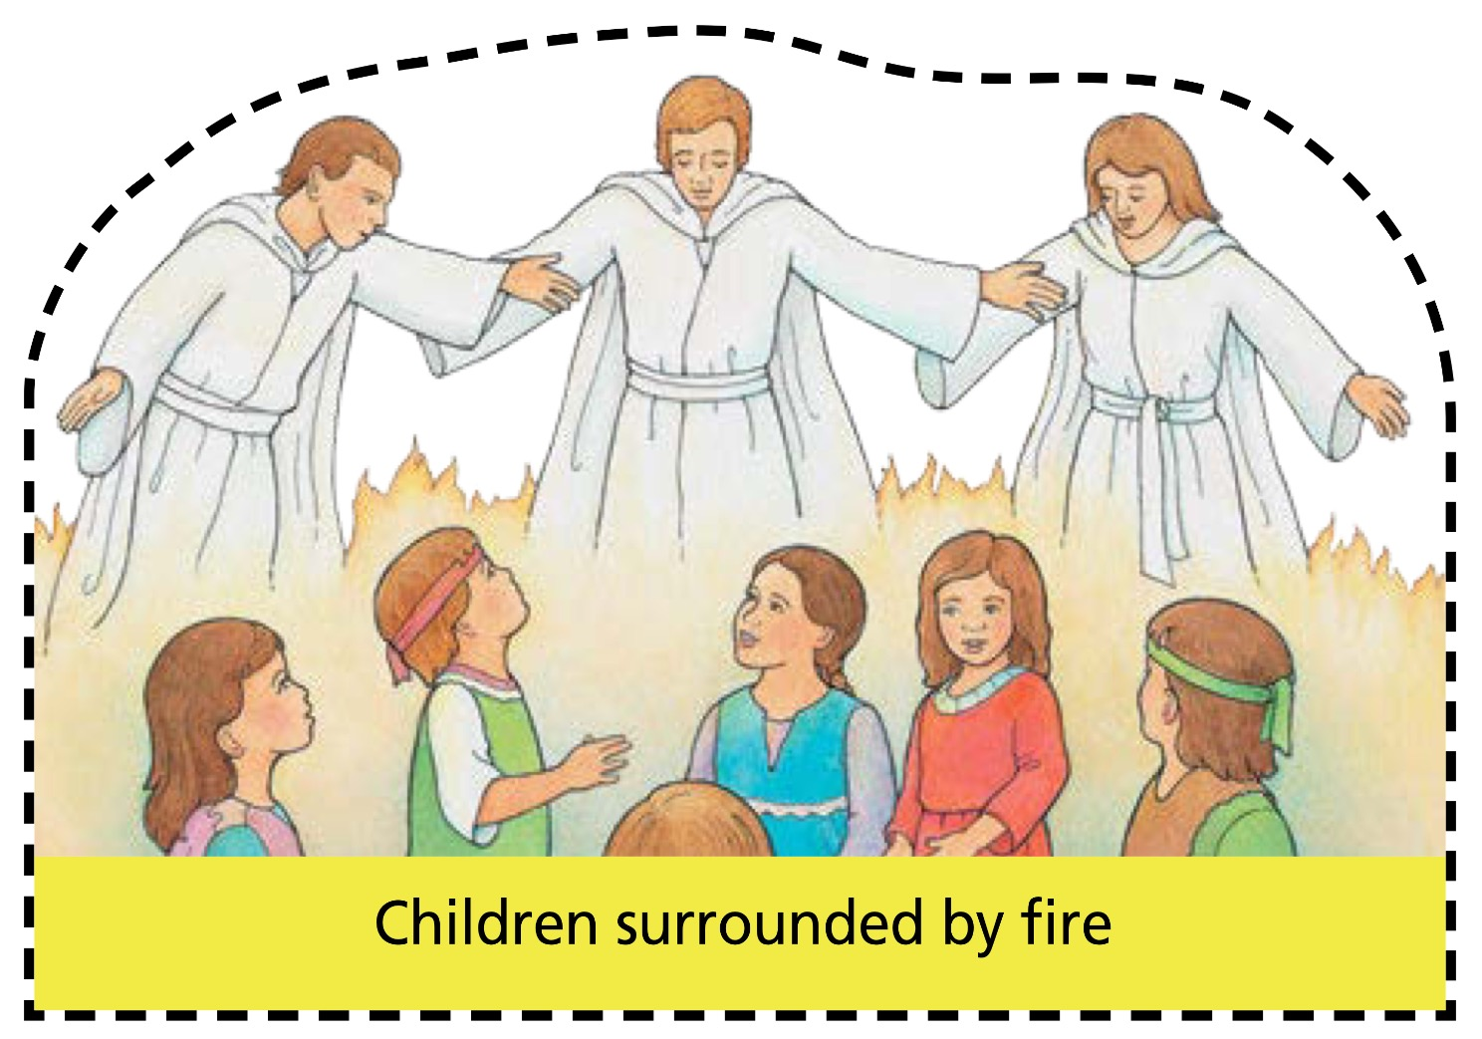



Concerned

Attentive



Helps

Prays



Supports

Comforts



Considerate

Teaches

Row 1 Row 2



Listens

Sacrifices



Patient

Forgiving







**Jesus Christ**

**Loves You**