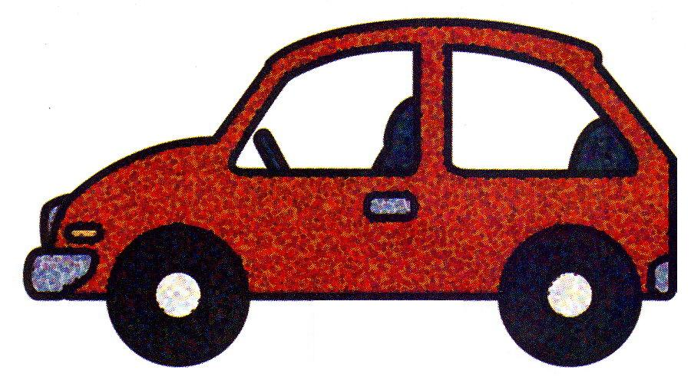

-----------------------------------------------------------------------------------------------------

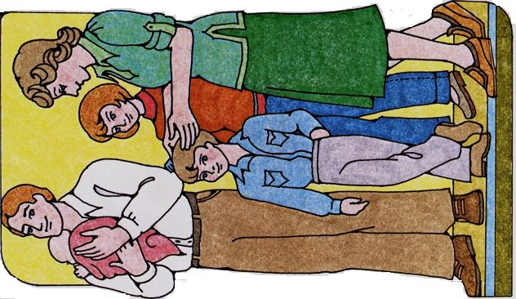

Car Picture - January Friend 2000 (insert),
Family picture – Primary manual cutouts

